## A Sampling of my Orchestral Arrangements—8 Brief Analyses

Here are brief analyses for eight orchestral arrangements (with links to videos), each of which speaks to one or more aspects of my orchestral arrangements. Scores of the arrangements can be found here [need link to PDF “8 Sample Orchestral Arrangements-SCORES” located in GREEN folder].

1. Haydn *Sinfonia No. 48 in C Major*, “Maria Theresia”: first movement (Allegro), Spring 2008.
2. Arturo Marquez *Danzon No. 2*: Spring 2013
3. Dvorak *Symphony No. 8 in G Major*, fourth movement (Allegro ma non troppo): Taking advantage of the overtone series for orchestration (Spring 2014)
4. Dvorak *Symphony No. 9 in E minor*: fourth movement (Allegro con fuoco)—Spring 2016
5. Gershwin *An American in Paris*: Spring 2017
6. Mozart *Serenade in Bb for 13 Winds*, K. 361: Finale—Spring 2019
7. Berlioz “Marche Hongroise” from *La Damnation de Faust*: Spring 2019
8. Mussorgsky-Ravel Selections from *Pictures at an Exhibition*—Promenade, Il vecchio castello, Tuileries, Cum mortuis in lingua mortua, and La cabane sur des pattes de poule: Spring 2023

**Haydn Sinfonia No. 48 in C Major, “Maria Theresia”: first movement (Allegro), Spring 2008.**

During the Spring 2008 term, OCO had none of the instruments called for in Haydn’s 48th Symphony, with the exception of timpani and strings, the latter of which comprised an unbalanced section of three violins, viola, and three cellos. Haydn’s No. 48 calls for 2 oboes, bassoon, 2 horns, 2 trumpets, timpani, and strings. In this recording and arrangement, I re-scored the work for 2 flutes, 3 clarinets, tenor saxophone, trumpet, euphonium, timpani, and the above string section. When Haydn wrote this work (ca. 1769), clarinets and flutes, not to mention saxophones, were not standard instrumentation. But all the students wanted to play this piece, so to develop a coherent Haydn sonority, I doubled strings with winds in their lowest registers so the winds would blend chameleon-like with the strings, e.g., the violins with flutes in their lowest register where their sonority is less ‘flutey’, as occurs in mm. 7-11: two of the violins are doubled with flute2 in its lowest register and violin3 is doubled with clarinet in its chalumeau register. I also blended one of the three clarinets with trumpet to camouflage the preponderance of clarinets by situating it within a brass sonority (e.g., clarinet3 with trumpet in mm. 5-9), and generally assigned two of the clarinets to the oboe parts. But what to do with the tenor saxophone? I treated this instrument as either a brass or woodwind, depending on context. For example, by combining it with trumpet in mm. 1-4, the tenor sax took on the quality of a horn, but then I ‘hid’ it right afterwards by merging it with the strings in mm. 5-11 where its register blends better with the harmonic support provided by the cellos in conjunction with the pedal points I assigned to flute1, clarinet2, clarinet3, and trumpet. (Haydn assigns these same pedal points to two horns and two trumpets.) At other times, I treated the tenor saxophone as a woodwind by using it to punctuate the cello parts, much as a bassoon would in the classical orchestra, e.g., mm. 30-41.

To vary the tonal palette (and keep the listener from latching onto any particular sonority for too long), as well as to give more melodic parts to the wind instruments (since they were complaining that the strings got all the good parts), I transferred the melody to the first clarinet in mm. 12-17 instead of keeping it in the first violins, as in the original Haydn score. In mm. 22-23, I substituted double stops in the upper 2 violin parts for the triple stops, to ensure the two violins would execute them exactly together. To create the ‘wood’ sound for the winds, I used clarinet1 on top and flute1 on bottom for the oboe lines in mm. 22-29, contrary to how flute and clarinet are usually positioned.

I employed the ‘sleight of hand’ of the above examples throughout this arrangement. For example, where Haydn writes a forte section only for the strings in mm. 103-111, I varied the sonority and reinforced the material with our winds and trumpet so that the sudden piano on the upbeat to m. 112 offered more contrast. It also provided melodic parts for the brass and wind sections.

***Evidence****:* The OCO recording of my arrangement of the Haydn can be heard at <https://youtu.be/knulC0k1r5M>

**Arturo Marquez Danzon No. 2: Spring 2013**

Marquez composed Danzon for a huge contemporary orchestra. OCO only had 13 players (2 flutes, tenor sax, French horn, 2 trumpets, piano, violin, viola, 2 cellos, and 2 percussionists.) To create the strong climaxes in the piece, I often pared down the texture, in order to build it up again. For example, Marquez opens Danzon with a full string section accompanying a clarinet solo. He also adds piano and claves. The claves give the ‘latin’ character to the work, so they had to remain. But instead of including his full piano part, which would not blend well with just 3 strings doing pizzicatos, I doubled the pizzicato cello with marimba. I then re-worked the clarinet solo for the other cello.

*Danzon* is filled with local and maximal climaxes. To set up the big climactic moments, I thinned the orchestration by eliminating instruments that play in the original score, sometimes adding a subito piano in the process. For example, the first strong arrival point in *Danzon* occurs at the Con fuoco (literally, “with fire”) in m. 74. I set that up by reducing the instrumentation starting in m. 66 by obliterating all the winds and brass of the original except for two flutes and French horn, writing a new part for the piano with the French horn sustaining the piano’s bass line, and adding a subito piano to each of the parts on the second beat of m. 66. I delayed bringing in the two trumpets, tenor sax, and bass drum until two measures before the Con fuoco.

The next climactic moment occurs in m. 145, according to the Marquez score (marked fortissimo). But for our orchestra, I imagined even more emphasis at mm. 150-151. So I kept our instruments forte at m. 145, replaced the repetitive piano part in mm. 145-153 with a new part reflecting the violins of the original score, then allocated the original pizzicato viola part to our violin and viola (both arco), and gave each of our two trumpets, tenor sax, and French horn dual roles: Each covered the roles of two different instruments, thus capturing the harmony of the original four horns, as well as the forte punctuating chords played in the original by two trumpets and three trombones from mm. 145-149.

Measures 256-280 illustrate a third strategy for setting up the illusion of huge forces with a small orchestra. A local climax occurs in m. 256, followed by a huge arrival point at m. 280. On the upbeat to m. 249, Marquez brings in the entire woodwind section which plays until the big Con fuoco section at m. 280. But to give more contrast and the illusion of powerful forces at m. 256, and then again at m. 280, I pared his woodwinds down to just two flutes playing an octave lower than the flutes of the original score and treated the tenor sax as a brass instrument. Then on the upbeat to m. 256, I took both flutes an octave higher to give a burst of energy to the local climax at m. 256. In mm. 261-267, I took out all the woodwinds again and delayed adding our two flutes until the upbeat to m. 268 where I put them both on the same part. I again paired the tenor saxophone (OCO’s only other woodwind) with our brass instruments so it (like a chameleon) assumed the color of the trumpets and French horn.

We had an exceptional marimbist/percussionist (David Pudlo), so I used the marimba to create color and carry lines originally scored for standard orchestral instruments or I combined an instrument in the original score with marimba. For example, in mm. 318-328, I doubled the treble part of the piano with the marimba. Up to that point, i.e., from mm. 282-316, the piano sonority had been prominent. Adding the marimba changed the texture and color from a piano to a hybrid instrument, the ‘mariano’, a totally made-up name but it gets the point across.

***Evidence:***  My arrangement can be heard in the 2013 OCO YouTube video recording <https://youtu.be/yyzEQ6n6OYA> The pianist (Philicia Chow) is excellent, yet she had to perform her big part on an electronic piano. Her playing made it clear we had to find a concert piano for future OCO concerts, which thankfully we did!

**Dvorak Symphony No. 8 in G Major, fourth movement (Allegro ma non troppo): Taking advantage of the overtone series for orchestration (Spring 2014)**

The orchestra selected the fourth movement of Dvorak’sSymphony No. 8 in G major, op. 88 (Allegro, ma non troppo). Dvorak scored his symphony for 2 flutes, 2 oboes, 2 clarinets, 2 bassoons, 4 horns, 2 trumpets, 2 trombones, bass trombone, tuba, timpani, and strings (32 violins, 12 violas, 12 cellos, and 8 double basses).

I then re-orchestrated the symphony for OCO’s 18 players (2 flutes, clarinet, bass clarinet, trumpet, baritone, 3 violins, 2 violas, 3 cellos, piano, and 3 percussionists).

In the score below, Dvorak wrote a part for the first violin section that takes them ever higher. But OCO only had two first violins, rather than 17. Playing the stratospheric passage as written would have resulted in a thin (and barely audible) climax.

So for the ending of the Dvorak, I brought our two first violins and single second violin an octave down from the Dvorak score. Then I wrote a short part for the glockenspiel that would ping the desired climactic high notes, and doubled the violins at the octave with the marimba (mm. 452-470). I counted on the octave overtones occurring in the lowered violin parts to contribute a string resonance to the marimba and glockenspiel parts. (The glockenspiel is a high, bell-like instrument which sounds 2 octaves higher than written.)

Though Dvorak doesn’t use a glockenspiel anywhere in his Eighth Symphony, I’ve often found it effective for adding “color” and sonority to OCO’s instrumentation. Since we had a good player, I gave her extra parts throughout the work, including the momentous sprint to the end.

Here is the original Dvorak score showing the high first violin parts in the top staff below:

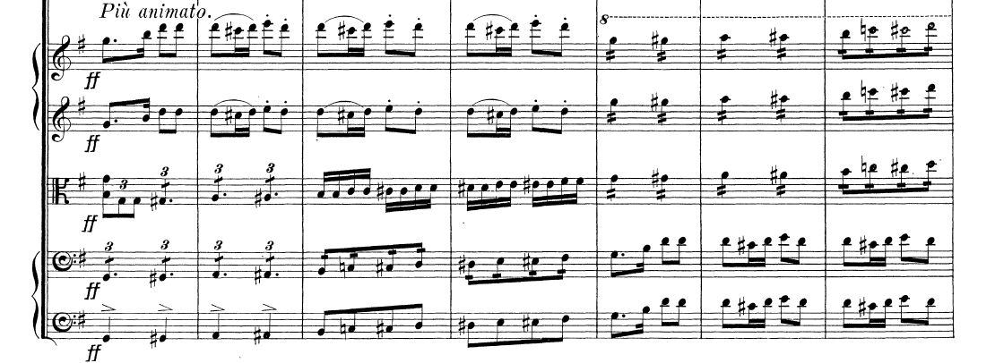

Here is my re-orchestration of the *Più animato* which brings all three violins an octave lower, starting in m. 450. The glockenspiel doubles the lowered violins at the octave so the violin overtones commingle with it. The marimba then doubles the glockenspiel, both of which double the lowered violins at the octave (mm. 452-461). From 462 to 465, it simulates the high tremolos of the first violins in Dvorak’s original scoring and continues to support the violins at the octave till m. 470. Finally, the glockenspiel ‘pings’ the last downbeat of the movement.

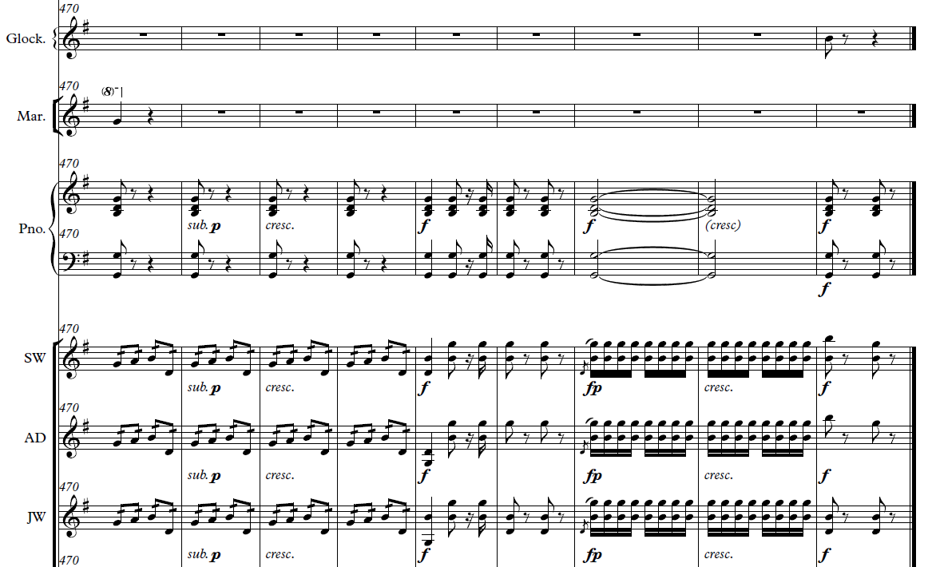

***Evidence****:*  My re-orchestration of the *Più animato* can be heard in the 2014 OCO YouTube video recording <http://bit.ly/OCO_Dvorak8>

**Dvorak Symphony No. 9 in e minor: fourth movement (Allegro con fuoco)—Spring 2016**

Dvorak scored his ninth symphony for 2 flutes, 2 oboes, 2 clarinets, 2 bassoons, 4 horns, 2 trumpets, 2 tenor trombones, bass trombone, timpani, percussion, and strings (34 violins, 14 violas, 12 cellos, and 8 double basses).

OCO had 2 flutes, 2 oboes, 2 clarinets, bass clarinet, trumpet, bass trombone, 6 violins, 2 violas, 3 cellos, harp, piano, and 2 percussionists.

In this symphony, Dvorak asks for 9 brass instruments. We only had two. But we had a pretty complete wind section. So I made myriad combinations of flutes, oboes, clarinets, and bass clarinet with trumpet and/or bass trombone to create the illusion of multiple differently-colored brass instruments. I used the piano to reinforce sections that needed more heft and added the harp when I could spare her on clarinet (she played both instruments).

Among other approaches, I used the glockenspiel and piano to not only ping but also buttress the violins where Dvorak sends them ever higher, as he did in the Eighth symphony. For example, in m. 39 he asks a large first violin section to reach for a B6, an octave and a fifth above the open E string. He doubles them with the first flute. But OCO had only two violins that could go for the high B. To create color, as well as a ‘wash’ over that note, I had the glockenspiel ‘ping’ it. Ditto for m. 182.

In mm. 201-213, Dvorak again writes an extremely high passage for the first violins. Though with practice, our violins could play this part, it would never sound as full as Dvorak intended. So I placed all six violins an octave lower and gave the pianist the same passage in right hand octaves and the glockenspiel the same passage in single notes. Then I told the glockenspiel player to “bang this out as loud as you can.” As with the Dvorak Eighth, I imagined the overtones of all six violins an octave lower would bathe the piano and glockenspiel parts with the string sonority, and that’s what happened. I used similar strategies in mm. 247-250, 277-280, 288-299, and 340-345.

***Evidence****:*  My arrangement can be heard in the 2016 OCO YouTube video recording <http://bit.ly/OCO_Dvorak9th> .

**Gershwin An American in Paris: Spring 2017**

The orchestration for *An American in Paris* calls for 24 woodwind and brass instruments. In Spring 2017 we only had nine. There are substantive parts in the original Gershwin for winds and brass, especially for clarinet and trumpet, including the memorable trumpet solos in the “Andante ma con ritmo deciso” section. We had no clarinet or trumpet, but we did have a pocket trumpet whose range was concert Bb3 to Eb5. The challenge was to convey the colors of a large brass section (eleven brass in the original Gershwin) with a woodwind section concentrated in the higher and lower ranges (comprising 3 flutes, oboe, and 2 bass clarinets) along with the 3 brass instruments we did have: trombone, bass trombone, and of course, the pocket trumpet.

This orchestration demanded much of the oboist. I did a first pass and then we met. He let me know where he needed to rest and what he could do given enough practice. On that basis, I made a revised arrangement which I continued to tweak according to what I heard during rehearsals. If we were close to a concert date, and I still heard players having difficulty, I revised passages and/or doubled them with other instrumments so that the passages came through more clearly and confidently.

To avoid too much of a particular timbre, I used instruments in their less identifiable registers, e.g., using the oboe in its poignant range for the beautiful melody starting between rehearsal marks 50 and 51 but also capturing the rhythmic countermelody by employing its lower register. (In the original Gershwin, the melody and countermelody are taken by two different instruments: the English horn and trumpet play the melody, whereas the oboe takes the countermelody.)

Producing a coherent group sound from this eclectic group of instruments was a challenge. Achieving balance was key. For example, I made a pizzicato part of Gershwin’s bassoon line at rehearsal 19, and dropped it an octave lower so the cello line could be clearly heard amidst the upper strings. The strings are a homogeneous family, i.e., they blend together well, so dropping the cello by an octave gave it a clearer voice.

Woodwinds, on the other hand, are not a homogeneous family of instruments. And because of that, they add distinctive color to an orchestration. But only having flute, oboe, and bass clarinet timbres challenged me to come up with combinations in just the right places at just the right times for audible color. For example, at rehearsal mark 20, I changed the color by giving all the original clarinet and bass clarinet parts to the piano, but then gave a woodwind hue to the piano part by doubling the left hand with one of our bass clarinets. Similarly, I added piano runs to rehearsal marks 38 and 39 not only to help out the winds and strings, especially with cohesion and technical concerns, but also to create timbral contrast. On the other hand, in the measure before rehearsal 41, I had no other option but to use the piano to capture the bassoon runs, but if I just put it there, the piano would stick out and not bring the passage to a blended conclusion. To remedy this, I added the piano timbre in the second and third measures before rehearsal 41 so it would be in the ‘mix’ or audible palette, i.e., combined with the flute and oboe runs, before emerging with its solo run in the measure before rehearsal 41.

*American* *in Paris* has no piano parts so I had to create one from scratch (since OCO had a good pianist), some of whose details I’ve discussed above. But there is a celeste part in *American* (rehearsal marks 42-45), and that’s an easy assignment to the piano. Still I made one change—prolonging the last chord at rehearsal mark 45 to match the held notes in the winds and strings (though the piano of course fades more quickly).

Whenever I came across a passage written for a single brass instrument, especially low brass, that I knew would demand too much individual practice from a player, I looked for ways to still achieve the line in the orchestration, often through re-distributing it. For instance, at rehearsal mark 22 in the original score, Gershwin gives a passage to the bass trombone filled with minor and major seventh jumps—a challenge for any player. Yet it was important for giving heft to the bass line. So I divided it between the bass trombone and trombone. It’s also fun and challenging for them because they have to play rhythmically in sync. I also re-distributed parts for the flutes, with dovetailing, e.g., two measures before rehearsal mark 66. In the original, these runs are taken by each flute in toto.

Sometimes I’ll re-distribute a line even if it’s easy for one instrument or section to play it. For instance, Gershwin writes a solo violin part in rehearsal 67 for just the concertmaster, but I could imagine the aural and visual effect of having each of three violins first pass it from one to another so I re-distributed the solo among them as a kind of musical relay.

Wherever possible, i.e., within the capacity of the pocket trumpet, I used it in combination with other instruments to create ‘hybrid’ timbres. For example, at rehearsal 70, I had the pocket trumpet bathe the oboe in its overtones by doubling it at the octave below. Similarly, I combined the oboe with flute to connote some of the ‘traffic’ sounds in *American* (originally scored for clarinet, as well as a special horn).

As I’ve done in many pieces, I used the glockenspiel to ping certain arrival points in the music, as well as contribute color, such as in rehearsal 28 where I created a glockenspiel line that floats above the others, from material originally given to the bass clarinet. In mm. 550-555, I used it for color and emphasis. Here, Gershwin writes an ‘open fifths’ passage reminiscent of the Beethoven Ninth that is doubled in all registers by the woodwinds (minus oboes and English horn), timpani, and strings. I added the glockenspiel, not at m. 550, but rather at m. 552 so the timbre of the passage changed midway during the repetitive passage, contributing emphasis as well.

***Evidence****:*  My arrangement can be heard in the 2017 OCO YouTube video recording <https://www.youtube.com/watch?v=BA5F48usRIo>

**Mozart Serenade in Bb for 13 Winds, K. 361: Finale—Spring 2019**

The Spring 19 woodwind section again comprised 3 flutes but now with an alto sax. The brass section included trumpet, tenor trombone, and euphonium. But we also had a pianist and timpanist. None of these instruments appear in Mozart’s Serenade. He scored it for 2 oboes, 2 clarinets, 2 basset horns, 4 horns, 2 bassoons, and double bass.

The first thing I did was expand the repeat signs: the Finale is in rondo form and each section of the rondo is repeated. By expanding the repeat signs, I was able to change instruments—and open the door for different dynamic markings—on the repeats. I made two versions of the Mozart. During Fall 2018, OCO had two trombones, one of whom studied away during Spring 2019. During the fall term, I switched the trombone parts on each repeat. During the spring term, I interchanged brass instruments on some repeats, e.g., trumpet and euphonium in mm. 65-80. I also paired the winds differently on the repeats, e.g., alto flute and alto saxophone in mm. 146-152, followed by flute2 and alto sax in mm. 153-160.

***Evidence****:*  My arrangement of the Spring 2019 Mozart can be heard in the 2019 OCO YouTube video recording <https://www.youtube.com/watch?v=hTNUGRU4Pl8>

**Berlioz “Marche Hongroise” from *La Damnation de Faust*: Spring 2019**

The challenge here was conveying a big, romantic bass line with only one cello (our Fall 2018 cellists were studying away during Spring 2019). Wherever possible, I doubled the cello at the octave with the alto sax, e.g., mm. 27-49, to give incision to the bass line (much as a bassoon would). At other times, I bolstered the cello line by doubling it with four violins at the octave, e.g., mm. 89-92 where the equally important counter line, heard in contrary motion, is buttressed by flutes, two violins, and right hand octaves in the piano. For the following measures, mm. 94-98, I took a different tack, doubling the cello with euphonium and alto sax.

The big, sustained climax of the Marche occurs in mm. 157-217, all marked fortissimo by Berlioz. The bass line melody starting at m. 157 has to be strong. I started by pairing the cello with the alto sax. so I kept the cello in a range that would also be strong in the alto sax. Next I added the trombone and euphonium, at first an octave apart, and then in unison (unison because the lowest, comfortable forte note for our euphonium player is E2), with the piano bass playing in octaves. To create dynamic contrast and excitement within these fortissimo measures, given a much smaller orchestra than that of Berlioz, I added two subito pianos, the first on the second beat of m. 166, and the second on the downbeat of m. 196. To avoid a thin texture in the violins for mm. 194-199, I dropped the top four violins an octave from what Berlioz had written and reinforced them with the flutes

***Evidence****:*  My arrangement of the Berlioz can be heard in the 2019 OCO YouTube video recording <https://www.youtube.com/watch?v=a9IkNITe1fE>

**Mussorgsky-Ravel Selections from Pictures at an Exhibition**—Promenade, Il vecchio castello, Tuileries, Cum mortuis in lingua mortua, and La cabane sur des pattes de poule: **Spring 2023**

A reorchestration for 10 players: 2 flutes, clarinet, alto sax, tenor sax, trumpet, 2 trombones, piano, and one violin.

As with all my reorchestrations (orchestral arrangements), OCO students select the repertoire they want to play; I then re-orchestrate the pieces for whatever instruments we have for that semester.

The students selected pieces from Mussorgsky’s *Pictures at an Exhibition* in the Ravel arrangement for large orchestra (including a sizeable string section, e.g., 38 violins, 14 violas, 12 cellos, and 8 double basses, as well as 2 flutes, piccolo, 3 oboes, 2 clarinets, alto saxophone, bass clarinet, 2 bassoons, contrabassoon, 4 horns, 2 trumpets, 3 trombones, tuba, timpani, and percussion).

Since Olin is a small school, we’ve never had standard instrumentation in the orchestra. Up to this point, I had made 135 orchestral arrangements for all combinations of instruments, trying to achieve the best group sound possible with unbalanced wind, string, and brass sections. But I’d never tried to balance one violin with 8 wind-brass and a piano for a work that requires a big orchestral sound; I wasn’t even sure it could be done.

Though the prospect of balancing that one violin was daunting, in some strange way I felt challenged. So I got to work on each of the 5 pieces selected by the students (Promenade, Il vecchio castello, Tuileries, Cum mortuis in lingua mortua, and La cabane sur des pattes de poule). I managed to balance the single violin with the other instruments, sometimes by writing parts that would allow the violin to soar above the other players, e.g., by creating harmonics, or integrating its timbre into the mix, e.g., by adding tremolos.

While re-orchestrating their last selection (Baba Yaga’s Hut), I found myself wishing we had a bass drum player and a timpanist, especially for its big beginning and subsequent recap. I was able to use every instrument in OCO to create a big group sound for the opening of Baba Yaga, with the exception of our 2 flutes. In their low range (where I needed them), they wouldn’t be heard. So why not have one flutist play timpani and the other play bass drum for the big beginning? I decided to turn them into percussionists just for the opening and recap, then give them a few measures to rush back to their seats, pick up their flutes, just in time for descending flute passages with grace notes.

To achieve more color throughout the orchestration, I gave the pianist not only a piano part but also parts on the glockenspiel, which she would learn to play. I also gave a trombonist a short parts on the xylophone. I then hired Sam Solomon, a gifted percussionist and teacher at Boston Conservatory, to give all of them a lesson on how to play their respective new instruments. The students took to their parts. After making this last re-orchestration, I felt we were in good shape for the final performances of the semester – Olin’s Exposition Day to be held May 9. I could clearly see a path forward to the end of the semester which would require work but all would be doable. So what could possibly go wrong?

On April 20, at the end of our rehearsal, the navigators (leaders) of the orchestra were reminding students of the times for the Expo concerts. Suddenly the pianist said, “wait, wait, what date are these concerts?”

“May 9,” replied the navigators. “I’ll be in China.” Her grandmother was gravely ill.

I really didn’t think we could do any of the Mussorgsky without the piano. Maybe the navigators would be able to find someone, but I wasn’t sure that would be successful given the piano technique required to play all pieces, especially that required for the last piece (Baba Yaga’s Hut) and given the time of year: end of semester finals. Also, the pianist would have to learn how to play the glockenspiel and move quickly between the two instruments, even playing one with the right hand (the piano), while playing the other with the left hand (glockenspiel).

The next week, at our OCO meeting, one of the navigators asked if I could do the piano parts. There was no other choice. So I learned all the piano and glockenspiel parts, and learned how to play the glockenspiel in the process. Here’s a clip that shows the Baba Yaga choreography with the flutists moving to timpani and bass drum and the trombonist moving from xylophone back to trombone (long link <https://youtu.be/7aBcnsstQkM> ). It’ll also show the 2 seconds I had to switch from piano to glockenspiel and then another 2 seconds to switch back to piano and place my hands 3 octaves apart to play a quick passage (quarter = 152). And it’ll show the group sound I created with an eclectic combination of 10 instruments. All five movements can be heard on Olin’s YouTube channel ( <https://www.youtube.com/watch?v=9icbmaUdWTA&list=PLvexLOJGQ74v0aFpdDdshzQHL2JAbwPXj&index=1> )

With hindsight, all’s well that ends well, but frankly, the easiest solution would’ve been to simply cancel the Expo performances. But that option didn’t occur to us.